More effective together: Successful exchange of findings at elero ProPartner events

Schlierbach, 06.07.2022 – The latest trends in the smart home sector, possible grants in the field of visual and sun protection, local marketing, as well as lots of time for networking and individual consultations: with this wide range of topics at its ProPartner events elero – Sun Shading Solutions Nice ensured that there was a successful mixture of information and the opportunity to exchange ideas and opinions. Following previous events in Hanover and Frankfurt, the series was concluded with an event for local partners in Augsburg on Friday, 1 July.

Live again at local level at last: the fact that the ProPartner events could be held again as normal this year following the coronavirus-driven pause was a source of pleasure for all the participants. “Direct and personal dialog with our local partner operations is not just a tradition but is something that is very important to us. And so we were very pleased that we could once again offer this platform and that demand was so great,” says Thomas Schürmann, Head of Sales at elero – Sun Shading Solutions Nice.

New solutions in the smart home sector under the umbrella of Nice
The interest of the specialist trade in innovations in the smart home sector was particularly great. As Florian Respondek, Field Sales Force, and Christoph Benz, Product Management, at elero – Sun Shading Solutions Nice, stated in their speech one in three people already uses smart home applications in their own home – and this figure is constantly rising. “The smart home opens up possibilities as applications are being called for in more and more areas. Above all open and expandable systems are in demand, therefore,” explained Respondek. With Yubii Nice and elero are offering a smart home system that takes into account the diverse needs of its clientele and depending on the individual demands meets the requirement for greater comfort, security and sustainability. The participants were able to experience and test the intelligent gateway Yubii Home and the flexibility of the possible applications in the system for themselves at the event.
Local branding for joint success
As well as innovations in the smart home sector, at the ProPartner events elero – Sun Shading Solutions Nice also presented its program for efficient local marketing. “Our approach is based on the idea that together we can achieve more than if everybody acts alone. Local measures and national advertising supplement and reinforce each other,” explained Inge Rappold, Head of Marketing at elero – Sun Shading Solutions Nice. The company is supporting its german partners in local marketing with a number of measures, ranging from billboard posters, through a target group-oriented social media campaign, to displays for showrooms. The new POS displays are available in three versions and can be filled in a modular manner. Thanks to their wood and steel construction they are not just appealing to the eye, but are also stable and durable.

Inspirational program
In addition, the program with specialist speeches allowed for an interesting view of the bigger picture. The authorised technical expert Olaf Vögele presented the latest possibilities for grants thanks to automated visual and sun protection. An outlook for future developments with regard to the topic of man and technology was provided by Prof. Fabian Hemmert. In his stimulating speech “What the future has to offer” he invited the audience to join him on a thought-provoking journey into the future and looked at the question of how we can preserve the human touch in an increasingly digital world.

With this mix of specialist topics, new ideas and the opportunity to exchange findings and opinions elero – Sun Shading Solutions Nice hit the mark as far as the trade audience was concerned. Melanie Bernwinkler from the window factory Fensterfabrik W. Niederhofer GmbH was full of praise for the inspiring speeches and was also impressed by the atmosphere: “elero has achieved international growth, but still has a great team with local roots that is there to help us. This is something you could very clearly sense here once again.” Mario Zepik from the company Zepik Rollladen GmbH added: “The input was very good and tailored to our needs. This made the long journey from Berlin well worthwhile.”
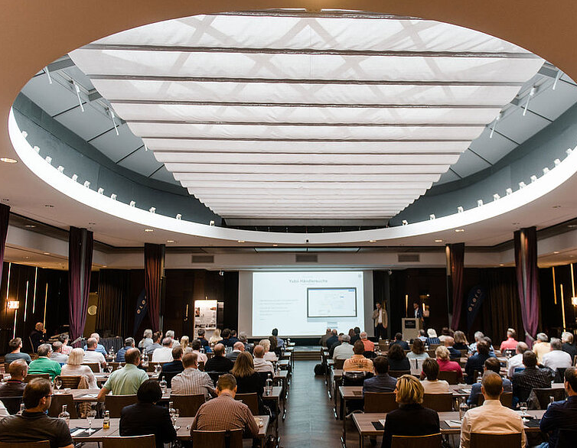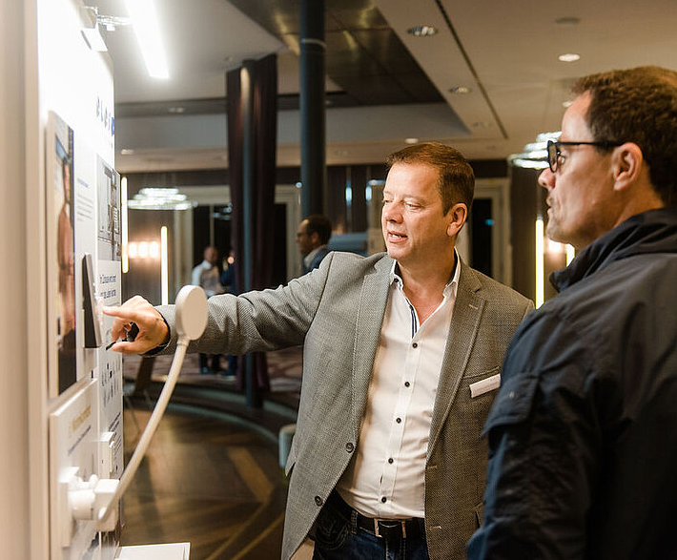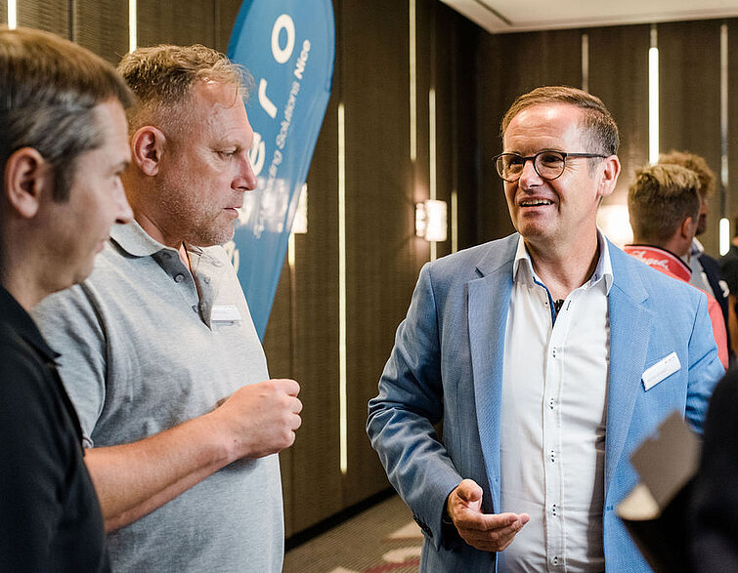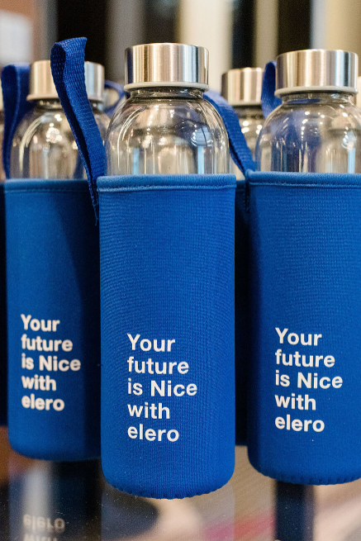
Photo 1: The mixture of product innovations, speeches on specialist topics and the opportunity for networking was greatly appreciated by the trade audience. (Photo: elero)

Photo 2: The trade audience were able to experience and test the benefits of the new smart home system Yubii at the ProPartner events. (Photo: elero)

Photo 3: Exciting speeches and innovations in the smart home sector field were a real talking point. (Photo: elero)

Photo 4: The combination of elero’s know-how with the strength of Nice as an international player ensures an optimistic outlook for the future. (Photo: elero)

elero - Nice Sun Shading Solutions
elero - Nice Sun Shading Solutions, based in Germany, Schlierbach near Stuttgart, is one of the world's largest manufacturers of electric drives and controls for roller shutters and sun shading systems, with a line dedicated to electric linear actuators. elero is a wholly owned and operated company of Nice. The two entities offer innovation and design in the management of light and sun shading, in residential, commercial, and industrial contexts, and the product portfolio is among the broadest on the market. elero solutions are renowned for their high-quality standards, backed by being Made in Germany.
For further information, visit www.elero.de

Nice
Founded in the early 1990s, Nice is a leading global solutions provider for Home & Building Management and Security, offering a full line of integrated systems for automating gates, garages, sun shades, parking systems, wireless alarm and home security systems for residential, commercial and industrial applications, as well as smart connected solutions for residential and commercial applications, security and access control, AI (artificial intelligence), health and wellness, control and power/AV. Nice has embarked on a strategic process of expanding and broadening its range and connected platforms to offer an ample selection of custom solutions and ease of use for the end consumer. In addition, it is expanding on markets with strong growth potential by renewing its branding efforts. Nice now boasts an organization of over 3,000 people on five continents with strong expertise and different cultural backgrounds, in addition to 15 R&D centres and 13 plants, serving its partners and customers in over 100 countries worldwide.
For further information, visit www.niceforyou.com.
LinkedIn I Facebook I Twitter I Instagram
#nice #niceforyou #smarthome #homesecurity #homeautomation

Press Contacts

Global Press Contact - Ernst & Young
Maria Elena Badini maria.elena.badini@it.ey.com Ph. +39 331 177 0516
Susanna Tagliento susanna.tagliento@it.ey.com Ph. +39 331 636 7029

German Press Contact - Wächter PR
Tanja Gottwald t.gottwald@waechter.team Ph. +49 (0)89/74 72 4275
Nice Global Press Contact
Elisa Chies el.chies@niceforyou.com Ph. +39 0422 505 406

Nice Sun Shading Solutions business unit, elero
Inge Rappold inge.rappold@elero.de Ph. +49 7021 9539 319

