New Nice Brasil Headquarters
is about to be ready!
Credits: Mario Cucinella Architects

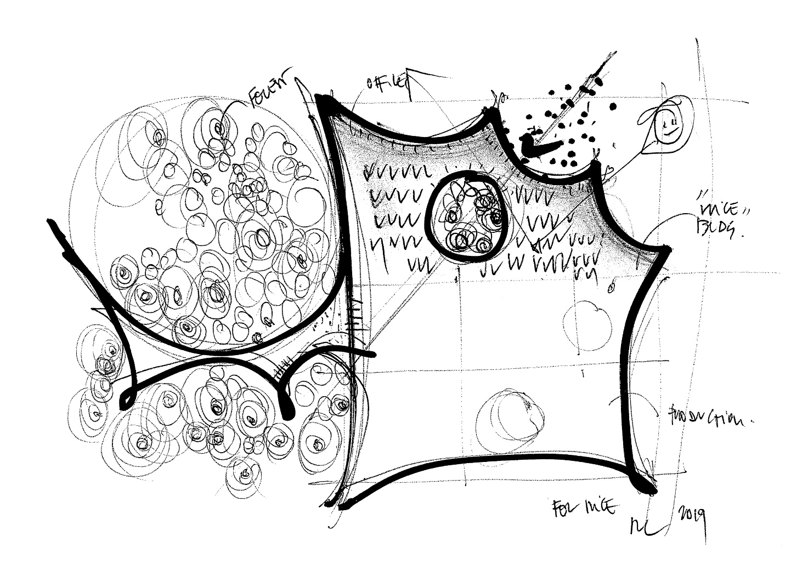

New Nice Brasil Headquarters
is about to be ready!

Oderzo, Italy, February 2022 - A giant leaf that gently sits on the building's pillars: this is the symbolic image that inspires the iconic roof of Nice's brand new industrial complex in Brazil, which will be inaugurated next June.

Nice, the Italian multinational global leader in Smart Home, Security, Home & Building Automation solutions, has entrusted the prestigious MC A - Mario Cucinella Architects studio with the design and realization of the new Brazilian headquarters of the company, a complex that is strongly avant-garde and eco-sustainable. Right now, construction work is going at a fast pace, with completion scheduled for June.

The futuristic complex will be in Limeira, northwest of São Paulo, and will cover an area of 20,000 square meters. Designed to meet LEED certification requirements, the building sets a benchmark for sustainable industrial architecture.

Nice's Brazilian headquarters has been conceived as a smart factory, inspired by the principles of Industry 4.0: a new production approach based on the use of cutting-edge technologies designed to improve working conditions, create a sustainable business model, and increase productivity and product quality of the plants. Realized with an investment of over 20 million euros, the complex will also be one of Nice's international R&D centers.

The project developed by MC A studio aims at reinterpreting the concept of 'production plant' by establishing a dialogue with the community and the surrounding environment. The building is characterized by a bright central front facing the main public roadway and it includes the lobby, two floors of offices, common areas, and a variety of meeting rooms. Production is located
on the back and is connected to the main atrium through a large window from which all visitors can observe the automated production process, transforming the structure into a "show-factory". Finally, a system of suspended pathways, surrounded by a forest, leads to another extension of the building that houses public facilities for employees.

Nice's new Brazilian headquarters is designed to reduce energy consumption through the use of a range of active and passive measures, which take advantage of favorable climatic conditions and allow the company's facilities and headquarters to operate completely off-grid for parts of the year without carbon emissions, supporting the CO2 reduction goals undertaken by the company globally. The building passively interacts with Limeira's mild climate by providing shade and allowing diffused light rays to all workspaces. The production area, thanks to the combination of thermal energy and natural ventilation, is fully operational all year round (without the need for additional cooling or heating), while the showroom and offices benefit from a mixed-use system that encourages the use of natural ventilation while reducing overall cooling need.

"Sustainability is a foundational element of architecture. If we think about the past, we have always had the need for a relationship with Earth and all its energies, such as the sun, the wind, the light. The project re-establishes a symbiotic relationship between the architectural structure and nature, interacting with the landscape and reinterpreting traditional Brazilian architectural elements, and encouraging the use of all its passive characteristics.", says Mario Cucinella founder and creative director of MC A - Mario Cucinella Architects.

"We have renewed our commitment to the realization of this project of great value, the result of very careful choices, from the centrality of the individual, to the selection of materials, to the technologies installed, which is part of our path towards sustainability at an international level. - declares Lauro Buoro, President and Founder of Nice - A company strategy that pays increasing attention to the environment and to the society in which we operate, to our way of doing business, to innovation. Nice's new Brazilian headquarters, designed by the prestigious Mario Cucinella Architects Studio, embodies these values and is intended to be a great opportunity for the development of the area and a new economic model capable of meeting the challenges of the contemporary world".

"The new Nice headquarters and production plant - adds Leonardo Sanchez, General Manager of Nice Brasil, a subsidiary of the Nice group since 2011 and a reference hub for the Latin American market - will represent a real turning point for the social and economic fabric of Limeira. It will be an avant-garde center that will offer its workers an innovative professional experience, where they can grow and constantly improve their skills, in line with Nice's values of diversity and inclusion. Other than being a complex project that takes into account social responsibility, integrating industry, community, and environment." - concludes Sanchez.

Project participants:
Mario Cucinella Architects Team: Mario Cucinella, Andrea Rossi (Project Director), Michele Olivieri (Design Leader), Alessio Naldoni, Elena Biason, Maria Pazzaglia, Mariangela Toscano, Angelo Ungarelli, Valerio Vincioni, Augusta Zanzillo, (BIM Coordinator), Yuri Costantini (Model maker).
Mario Cucinella Visual Team: Alessia Monacelli, Guglielmo Barbieri (Mario Cucinella Architects).

Nice
Founded in the early 1990s, Nice is a world leader in the Smart Home, Home Security and Home and Building Automation markets. It has a comprehensive offering of integrated solutions for the automation of gates, garage doors, solar protection, parking systems, wireless alarm systems and home security in residential, commercial and industrial buildings. Nice has launched a strategic plan to expand and broaden its portfolio of products and connected platforms. It offers a wide range of customizable and easy-to-use options for the end user and seeks to strengthen and expand in markets with high growth potential, improving and renewing ist brand to compete in new market segments. Nice exports its products, which combine technological innovation and design, to more than 100 countries.
For more information visit: www.niceforyou.com.
LinkedIn I Facebook IFacebook Twitter I Instagram
#nice #niceforyou #smarthome #homesecurity #homeautomation
MC A - Mario Cucinella Architects
Mario Cucinella Architects is an architectural firm with offices in Bologna and Milan and an international team of one hundred professionals including architects, engineers, graphic designers, model makers and researchers. The firm was established in Paris in 1992 and opened its offices in Bologna in 1999. MC A has extensive experience in architectural design that combines environmental and energy efficiency strategies and relies on an R&D department that carries out research on sustainability with a holistic approach. All projects have in common a focus on technological integration with environmental and climate strategies to build buildings that can reduce their environmental impact in view of the 2020 and 2030 European objectives, contributing to mitigation and adaptation to climate change impacts, on the one hand, and have a positive social impact through greater public participation and sharing of the design and urban transformation processes, on the other www.mcarchitects.it

Contact

Nice HQ Italy |  | Wächter PR Germany
Elisa Chies  el.chies@niceforyou.com | Martina Tommasi  m.tommasi@niceforyou.com | Wächter PR  Tanja Gottwald  t.gottwald@waechter.team  +49 (0)89/74 72 42-75
MC A - Mario Cucinella Architects
Christiane Bürklein  Christiane.Burklein@mcarchitects.it | Alessia Ravaldi  Alessia.ravaldi@mcarchitects.it

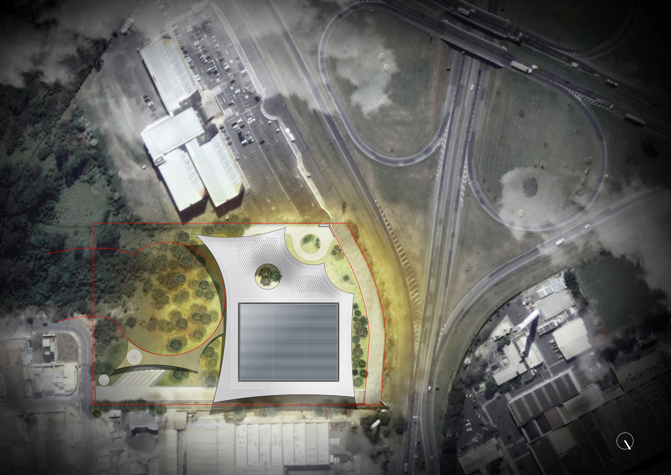
Credits: Mario Cucinella Architects

